**Assignment - 4**

**1.Create ASP.NET webpage that will take User’s Name & Favorite Color from TextBox & Dropdownlist .before submitting values check whether values are empty or not using Required Field Validator.**

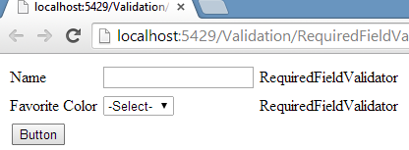

Add TextBox Control

Add RequireValidator : ToolBox > Validation > RequireValidator

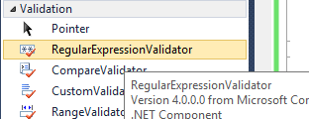



Now select ControlToValidate function and select TextBox Control



Then set ErrorMessage Property = Name Required!!!



Add and DropDownList Control

Add RequireValidator : ToolBox > Validation > RequireValidator



Now select ControlToValidate function and select TextBox Control



Then set ErrorMessage Property = pls Select Color



**2.Create ASP.NET Webpage that will take valid date from user into textbox control using Range validator.**

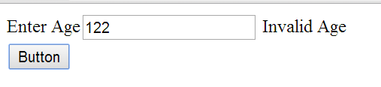

Add TextBox Control

Add RangeValidator : ToolBox > Validation > RangeValidator

Now select ControlToValidate function and select TextBox Control



Then set Property ErrorMessage = invalid Age

Add RequireValidator : ToolBox > Validation > RequireValidator

Now select ControlToValidate function and select TextBox Control



set Property ErrorMessage = Age Required

**3.Create ASP.NET Webpage that will check validation using Compare Validation:**

**i) Check the Data Type Of Bdate**

**ii) Check Bdate must be greater than now/today.**

**iii) Check End Date Must be Greater than Start Date.**

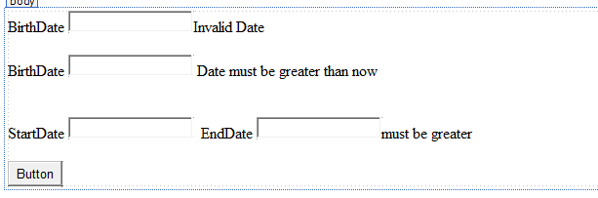

**Add all the web controls with respective Validation Controls(i.e Compare Validation)**

**Properties selection for validation controls:**

Select properties of first validation control

1. ControlToValidate="TextBox1"
2. ErrorMessage="Invalid Date"
3. Operator="DataTypeCheck"
4. Type="Date"

Select properties of second validation control

ControlToValidate="TextBox2"

ErrorMessage="Date must be greater than now"

Operator="GreaterThan"

Type="Date"

ValueToCompare="17-07-14"

Select properties of third validation control

ControlToCompare="TextBox3"

ControlToValidate="TextBox4"

ErrorMessage="must be greater"

Operator="GreaterThan"

Type="Date"

**4.Create ASP.NET Webpage that will take valid email address and valid URL using Regular Expression Validation Control.**

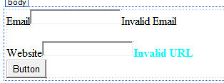

**Add all the web controls with respective Validation Controls(i.e Regular Validation)**

**Properties selection for validation controls:**

Select First Regular Expression Validation Control and select its properties:

ErrorMessage="Invalid Email"

ControlToValidate="TextBox1"

When u select ValidationExpression ,u have to select proper validation pattern or expression.



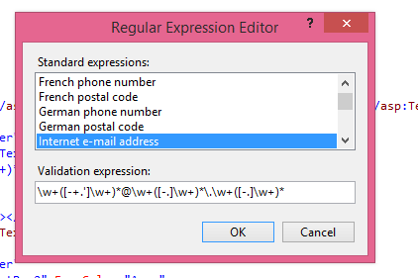

Repeat same above step for URL Regular Expression Validation Control and select its properties:

ErrorMessage="Invalid Email"

ControlToValidate="TextBox1"

ValidationExpression ,select internet URL .

1. **Create ASP.NET Webpage that will not allow user to enter more than 10 characters.**

**Use custom validator.**

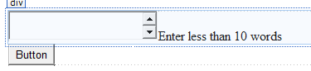

**Add all the web control with respective Validation Control(Regular Custom validation)**

**Properties selection for validation controls:**

ErrorMessage="Enter less than 10 words"

ControlToValidate="TextBox1"

ClientValidationFunction="hello" ,now create “Hello” javascript function in <head> <script> tag and write code for validation.

<head runat="server">

<title></title>

<script type="text/javascript">

function hello(source, args) {

if (args.Value.length > 10)

args.IsValid = false;

else

args.IsValid = true;

}

</script>

</head>

1. **Create ASP.NET Webpage that registration details like Username,Password,Confirm Password from user ,assign validation controls onall the fields and display validation errormessage into validation summary control.**

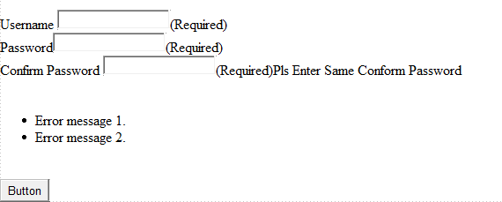

**Add all the web controls with respective Validation Controls and at bottom of the form add validation summary control where we are going to display validation summary.**

**Set all the Properties for validation controls and write proper message in to ErrorMessage Property:**

Drag validation summary control and set its properties.



